Lab 8: Foreign Keys and Relationships

Part 1. Parent tables and foreign key methods

Step 1. Create a schema and the parent tables
DROP SCHEMA IF EXISTS lab8 CASCADE;
CREATE SCHEMA lab8;
SET search_path TO lab8;
CREATE TABLE students (
student_id SERIAL PRIMARY KEY,
name VARCHAR(100) NOT NULL,
email VARCHAR(150) UNIQUE
);
CREATE TABLE courses (
course_id SERIAL PRIMARY KEY,
course_name VARCHAR(100) NOT NULL
);
INSERT INTO students (name, email) VALUES
('Zhamilya Kambaraalieva', 'zhamilya@alatoo.edu.kg'),
('Aibek Toktorov', 'aibek@alatoo.edu.kg'),
('Aigerim Asanova', 'aigerim@alatoo.edu.kg');
INSERT INTO courses (course_name) VALUES ('Databases'), ('Algorithms'), ('Web Development');
SELECT * FROM students;
SELECT * FROM courses;
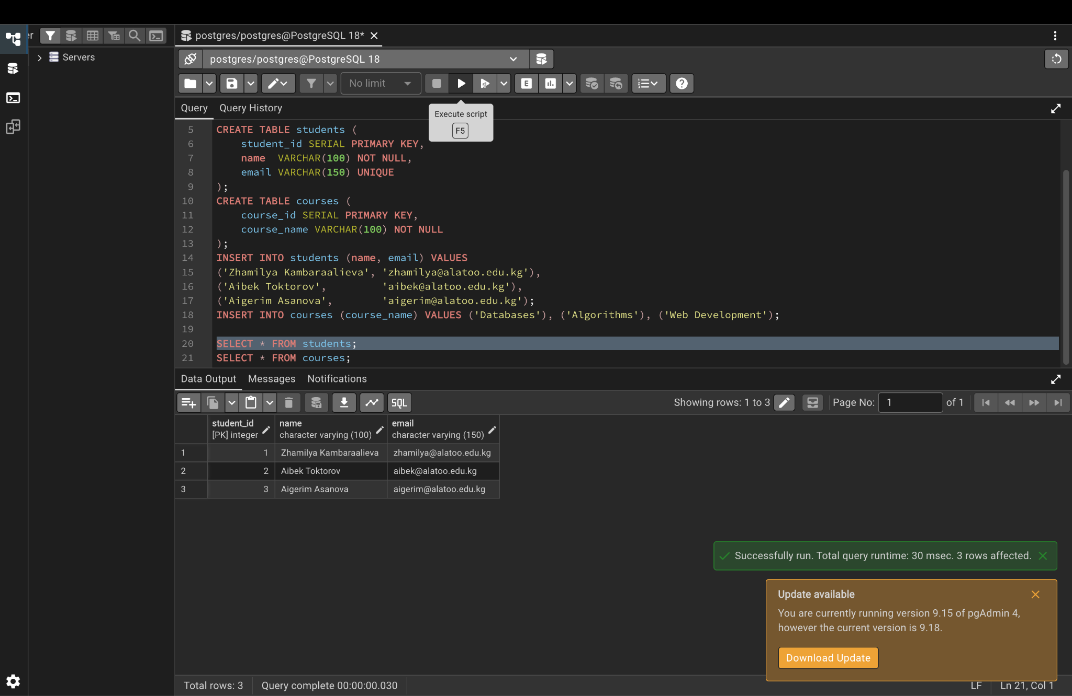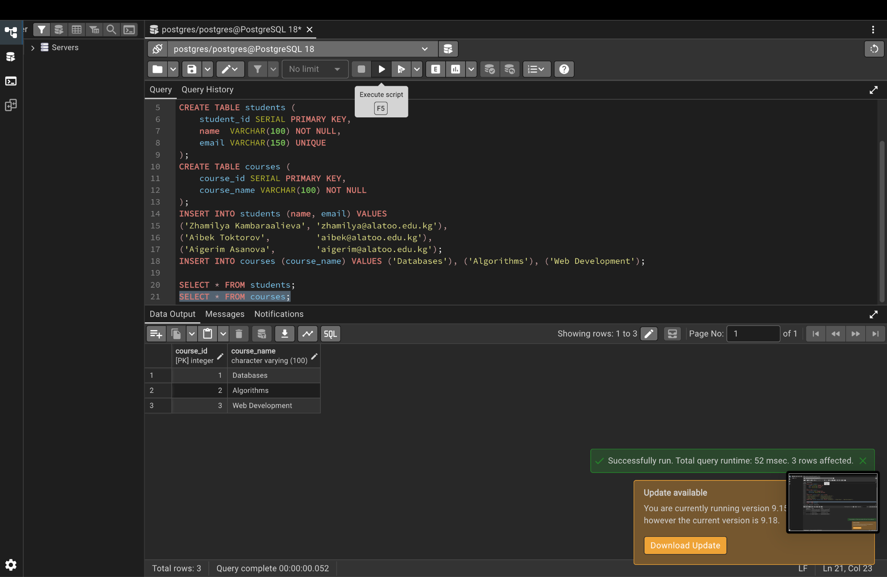

Step 2. Four ways to create a foreign key
Inline, table-level, added later with ALTER TABLE, and named constraint.
CREATE TABLE fk_method1 ( -- inline
id SERIAL PRIMARY KEY,
student_id INTEGER REFERENCES students(student_id)
);
CREATE TABLE fk_method2 ( -- table-level
id SERIAL PRIMARY KEY,
student_id INTEGER,
FOREIGN KEY (student_id) REFERENCES students(student_id)
);
CREATE TABLE fk_method3 ( -- added later
id SERIAL PRIMARY KEY,
student_id INTEGER
);
ALTER TABLE fk_method3
ADD CONSTRAINT fk_method3_student FOREIGN KEY (student_id) REFERENCES students(student_id);
CREATE TABLE fk_method4 ( -- named constraint
id SERIAL PRIMARY KEY,
student_id INTEGER,
CONSTRAINT fk_method4_student FOREIGN KEY (student_id) REFERENCES students(student_id)
);
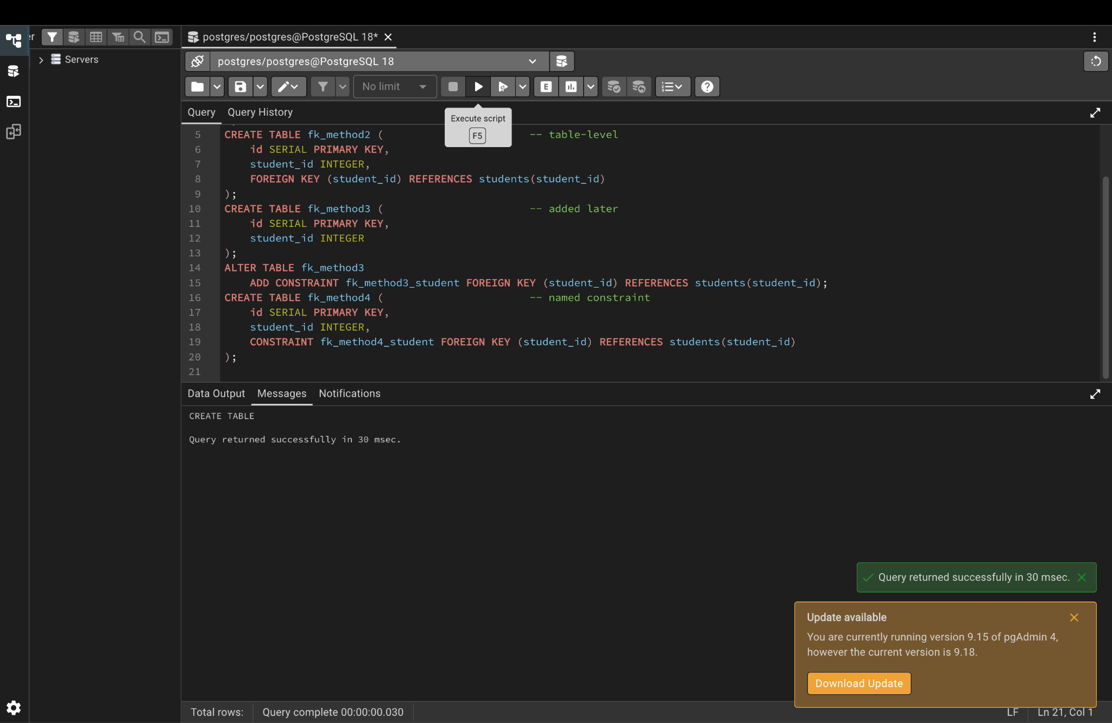

Part 2. CASCADE options

Step 3. Create a department table and four child tables
Each child table uses a different ON DELETE / ON UPDATE option.
CREATE TABLE departments (
dept_id INTEGER PRIMARY KEY,
dept_name VARCHAR(100)
);
INSERT INTO departments VALUES (0, 'Unassigned'), (1, 'Computer Science'), (2, 'Mathematics'), (3, 'Physics');
CREATE TABLE emp_cascade (
emp_id SERIAL PRIMARY KEY, name VARCHAR(50),
dept_id INTEGER REFERENCES departments(dept_id) ON DELETE CASCADE ON UPDATE CASCADE
);
CREATE TABLE emp_set_null (
emp_id SERIAL PRIMARY KEY, name VARCHAR(50),
dept_id INTEGER REFERENCES departments(dept_id) ON DELETE SET NULL
);
CREATE TABLE emp_set_default (
emp_id SERIAL PRIMARY KEY, name VARCHAR(50),
dept_id INTEGER DEFAULT 0 REFERENCES departments(dept_id) ON DELETE SET DEFAULT
);
CREATE TABLE emp_restrict (
emp_id SERIAL PRIMARY KEY, name VARCHAR(50),
dept_id INTEGER REFERENCES departments(dept_id) ON DELETE RESTRICT
);
INSERT INTO emp_cascade (name, dept_id) VALUES ('Aliya', 1), ('Bakyt', 2);
INSERT INTO emp_set_null (name, dept_id) VALUES ('Chingiz', 2);
INSERT INTO emp_set_default (name, dept_id) VALUES ('Dana', 2);
INSERT INTO emp_restrict (name, dept_id) VALUES ('Emil', 3);

Step 4. Show the data BEFORE changing the parent table
SELECT 'cascade' AS tbl, name, dept_id FROM emp_cascade
UNION ALL SELECT 'set_null', name, dept_id FROM emp_set_null
UNION ALL SELECT 'set_default', name, dept_id FROM emp_set_default
UNION ALL SELECT 'restrict', name, dept_id FROM emp_restrict;
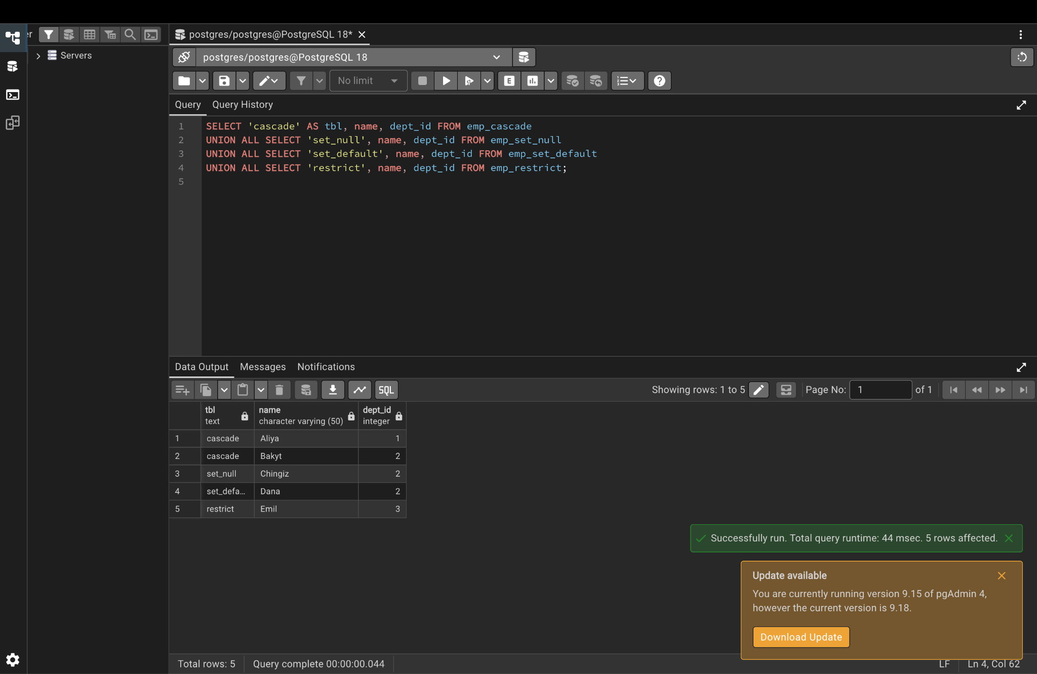

Step 5. Update and delete parent rows, then show the data AFTER
Expected: Aliya moves to 10 (ON UPDATE CASCADE), Bakyt is deleted (CASCADE), Chingiz gets NULL (SET NULL), Dana gets 0 (SET DEFAULT).
UPDATE departments SET dept_id = 10 WHERE dept_id = 1;
DELETE FROM departments WHERE dept_id = 2;
SELECT 'cascade' AS tbl, name, dept_id FROM emp_cascade
UNION ALL SELECT 'set_null', name, dept_id FROM emp_set_null
UNION ALL SELECT 'set_default', name, dept_id FROM emp_set_default
UNION ALL SELECT 'restrict', name, dept_id FROM emp_restrict;
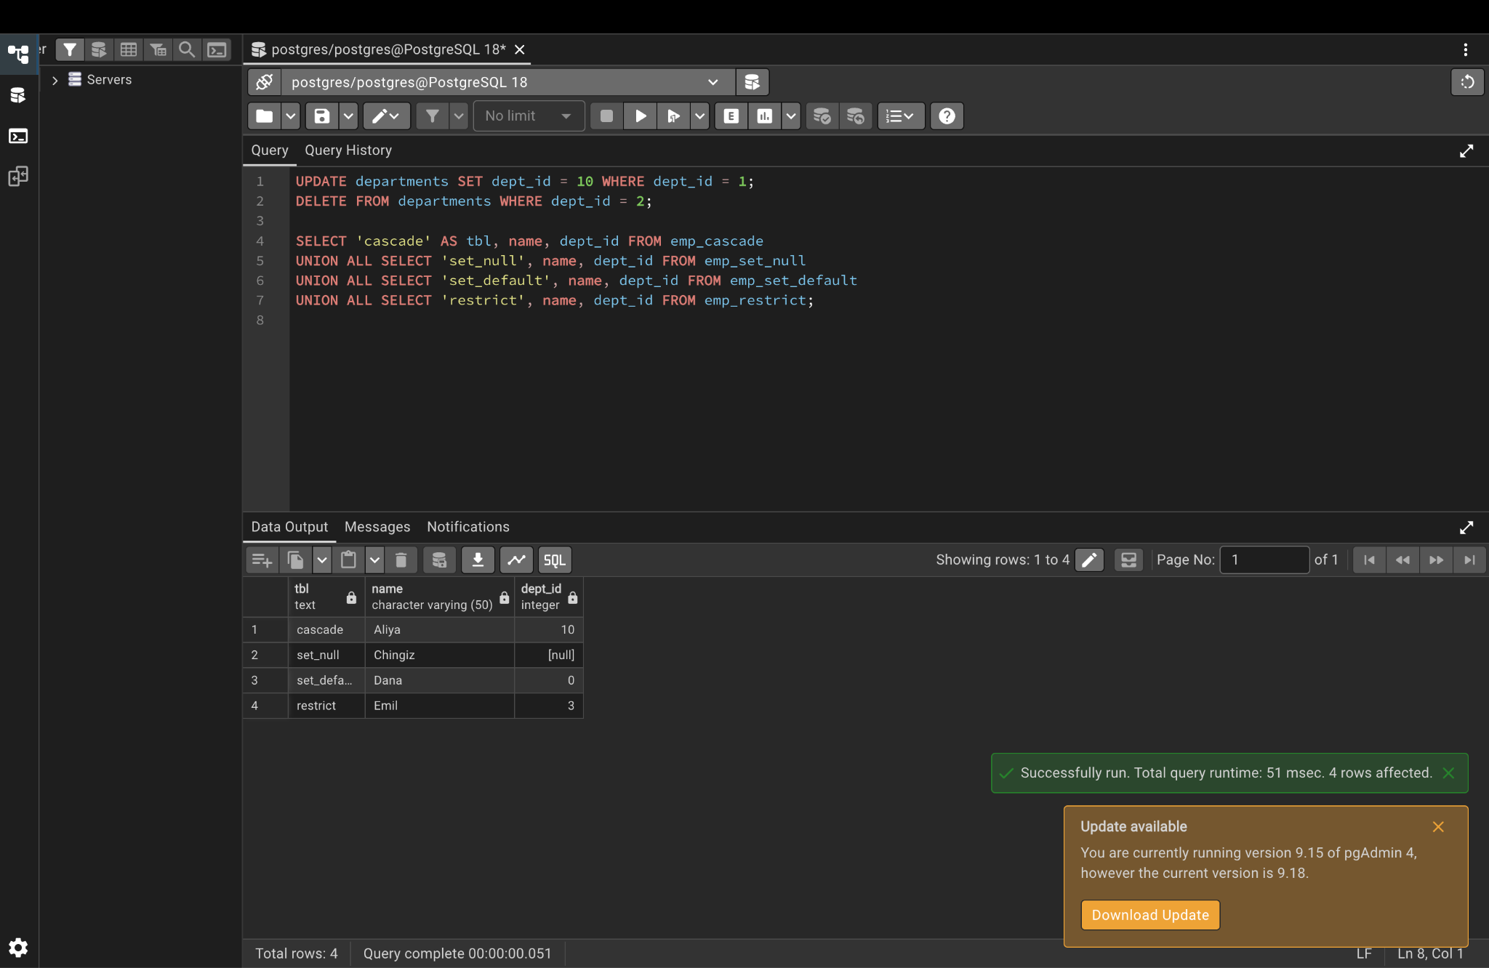

Part 3. One-to-one relationship

Step 6. Student profiles (FK + UNIQUE) and passports (shared primary key)
CREATE TABLE student_profiles (
profile_id SERIAL PRIMARY KEY,
student_id INTEGER UNIQUE NOT NULL REFERENCES students(student_id) ON DELETE CASCADE,
address VARCHAR(200),
phone VARCHAR(20)
);
INSERT INTO student_profiles (student_id, address, phone) VALUES
(1, 'Bishkek, Chui Ave 10', '+996700111111'),
(2, 'Bishkek, Manas Ave 5', '+996700222222');
CREATE TABLE student_passports (
student_id INTEGER PRIMARY KEY REFERENCES students(student_id) ON DELETE CASCADE,
passport_no VARCHAR(20) UNIQUE
);
INSERT INTO student_passports VALUES (1, 'ID1234567'), (3, 'ID7654321');
SELECT s.name, p.address, p.phone
FROM students s JOIN student_profiles p ON s.student_id = p.student_id;
SELECT s.name, pp.passport_no
FROM students s JOIN student_passports pp ON s.student_id = pp.student_id;
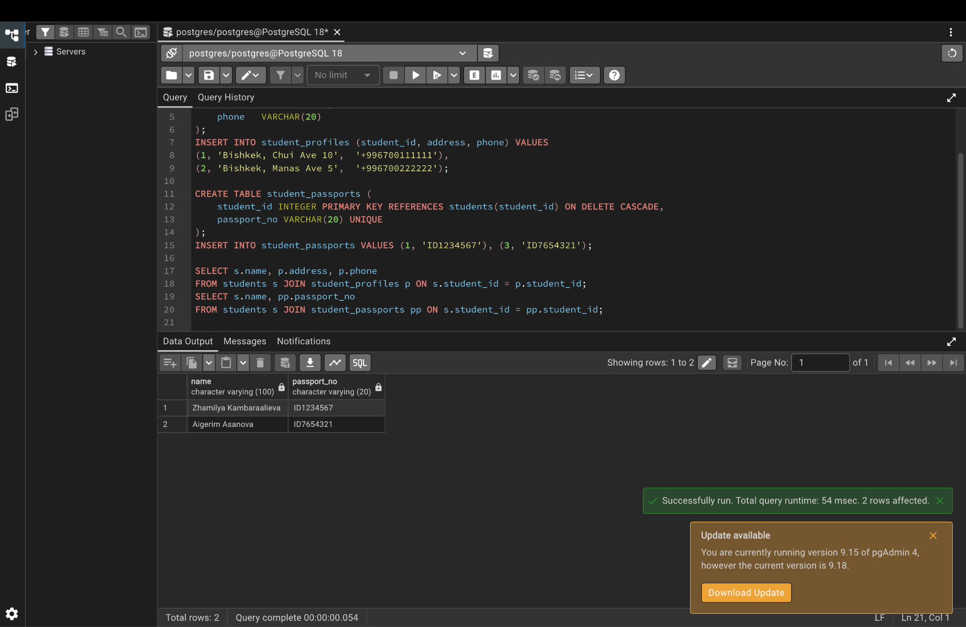

Part 4. One-to-many relationship

Step 7. One instructor teaches many courses
CREATE TABLE instructors (
instructor_id SERIAL PRIMARY KEY,
name VARCHAR(100) NOT NULL
);
ALTER TABLE courses ADD COLUMN instructor_id INTEGER REFERENCES instructors(instructor_id);
INSERT INTO instructors (name) VALUES ('Dr. Ivanov'), ('Dr. Sydykova');
UPDATE courses SET instructor_id = 1 WHERE course_id IN (1, 2);
UPDATE courses SET instructor_id = 2 WHERE course_id = 3;
SELECT i.name AS instructor, c.course_name
FROM instructors i JOIN courses c ON i.instructor_id = c.instructor_id
ORDER BY i.name;
SELECT i.name AS instructor, COUNT(c.course_id) AS courses_taught
FROM instructors i LEFT JOIN courses c ON i.instructor_id = c.instructor_id
GROUP BY i.name;
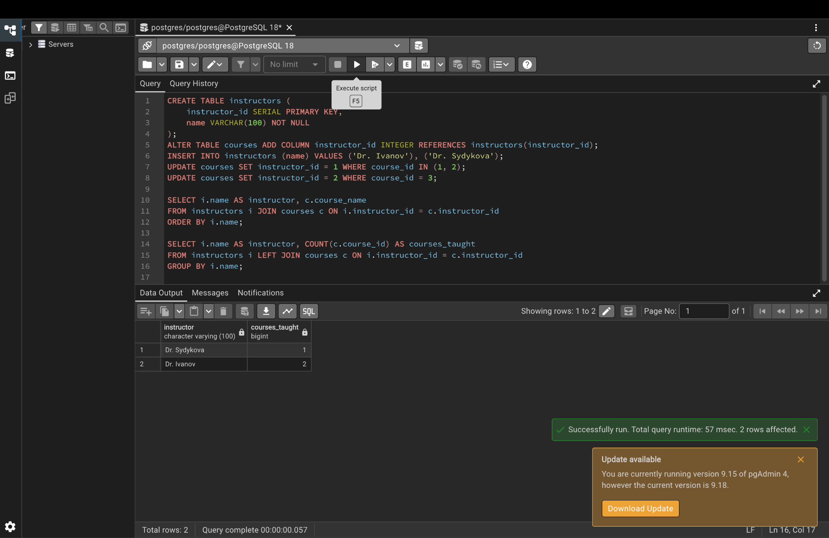

Part 5. Many-to-many relationship

Step 8. Students and courses through the enrollments junction table
CREATE TABLE enrollments (
student_id INTEGER REFERENCES students(student_id) ON DELETE CASCADE,
course_id INTEGER REFERENCES courses(course_id) ON DELETE CASCADE,
enrollment_date DATE DEFAULT CURRENT_DATE,
grade CHAR(2),
PRIMARY KEY (student_id, course_id)
);
INSERT INTO enrollments (student_id, course_id, grade) VALUES
(1, 1, 'A'), (1, 2, 'A-'), (1, 3, 'B+'),
(2, 1, 'B'), (2, 3, 'A'),
(3, 2, 'A');
SELECT s.name AS student, c.course_name, e.grade
FROM enrollments e
JOIN students s ON e.student_id = s.student_id
JOIN courses c ON e.course_id = c.course_id
ORDER BY s.name, c.course_name;
SELECT c.course_name, COUNT(e.student_id) AS students_enrolled
FROM courses c LEFT JOIN enrollments e ON c.course_id = e.course_id
GROUP BY c.course_name;
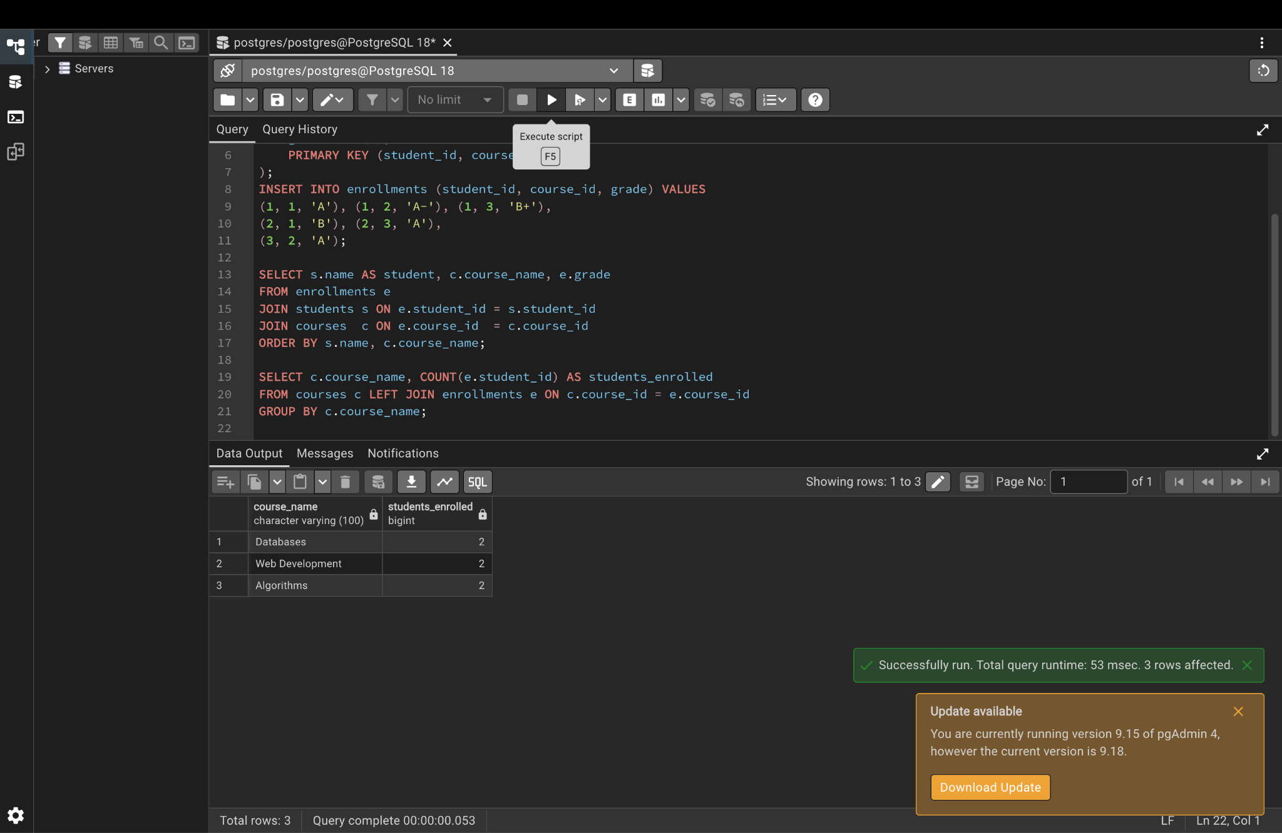

Step 9. List every foreign key in this lab
SELECT conrelid::regclass AS table_name, conname AS constraint_name,
pg_get_constraintdef(oid) AS definition
FROM pg_constraint
WHERE contype = 'f' AND connamespace = 'lab8'::regnamespace
ORDER BY 1;
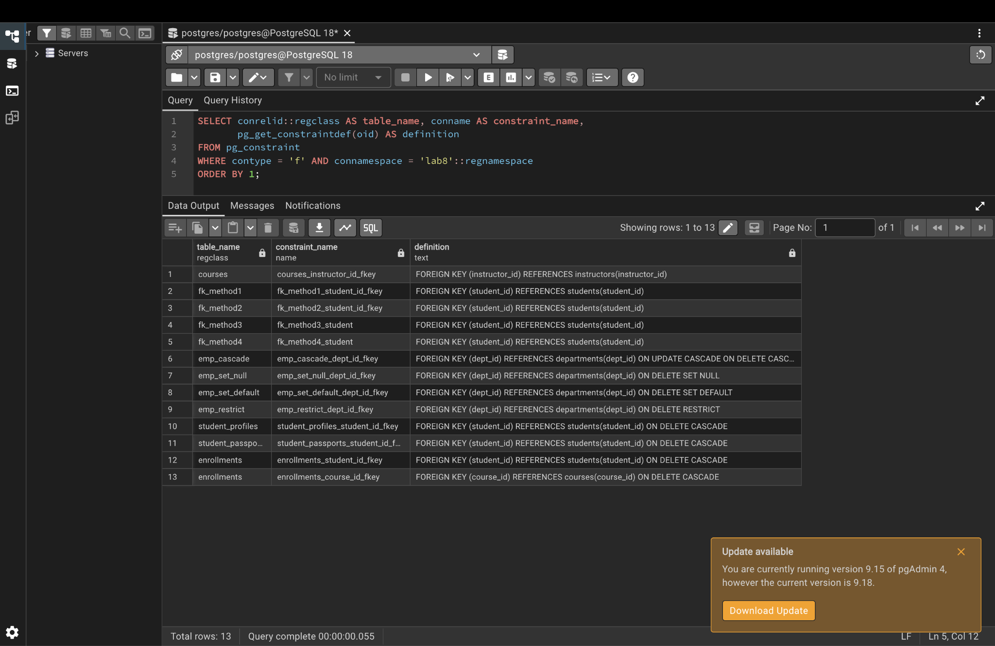

Part 6. Proving referential integrity (each command should give an ERROR)

Step 10. Insert rule: student 99 does not exist
SET search_path TO lab8;
INSERT INTO enrollments (student_id, course_id) VALUES (99, 1);
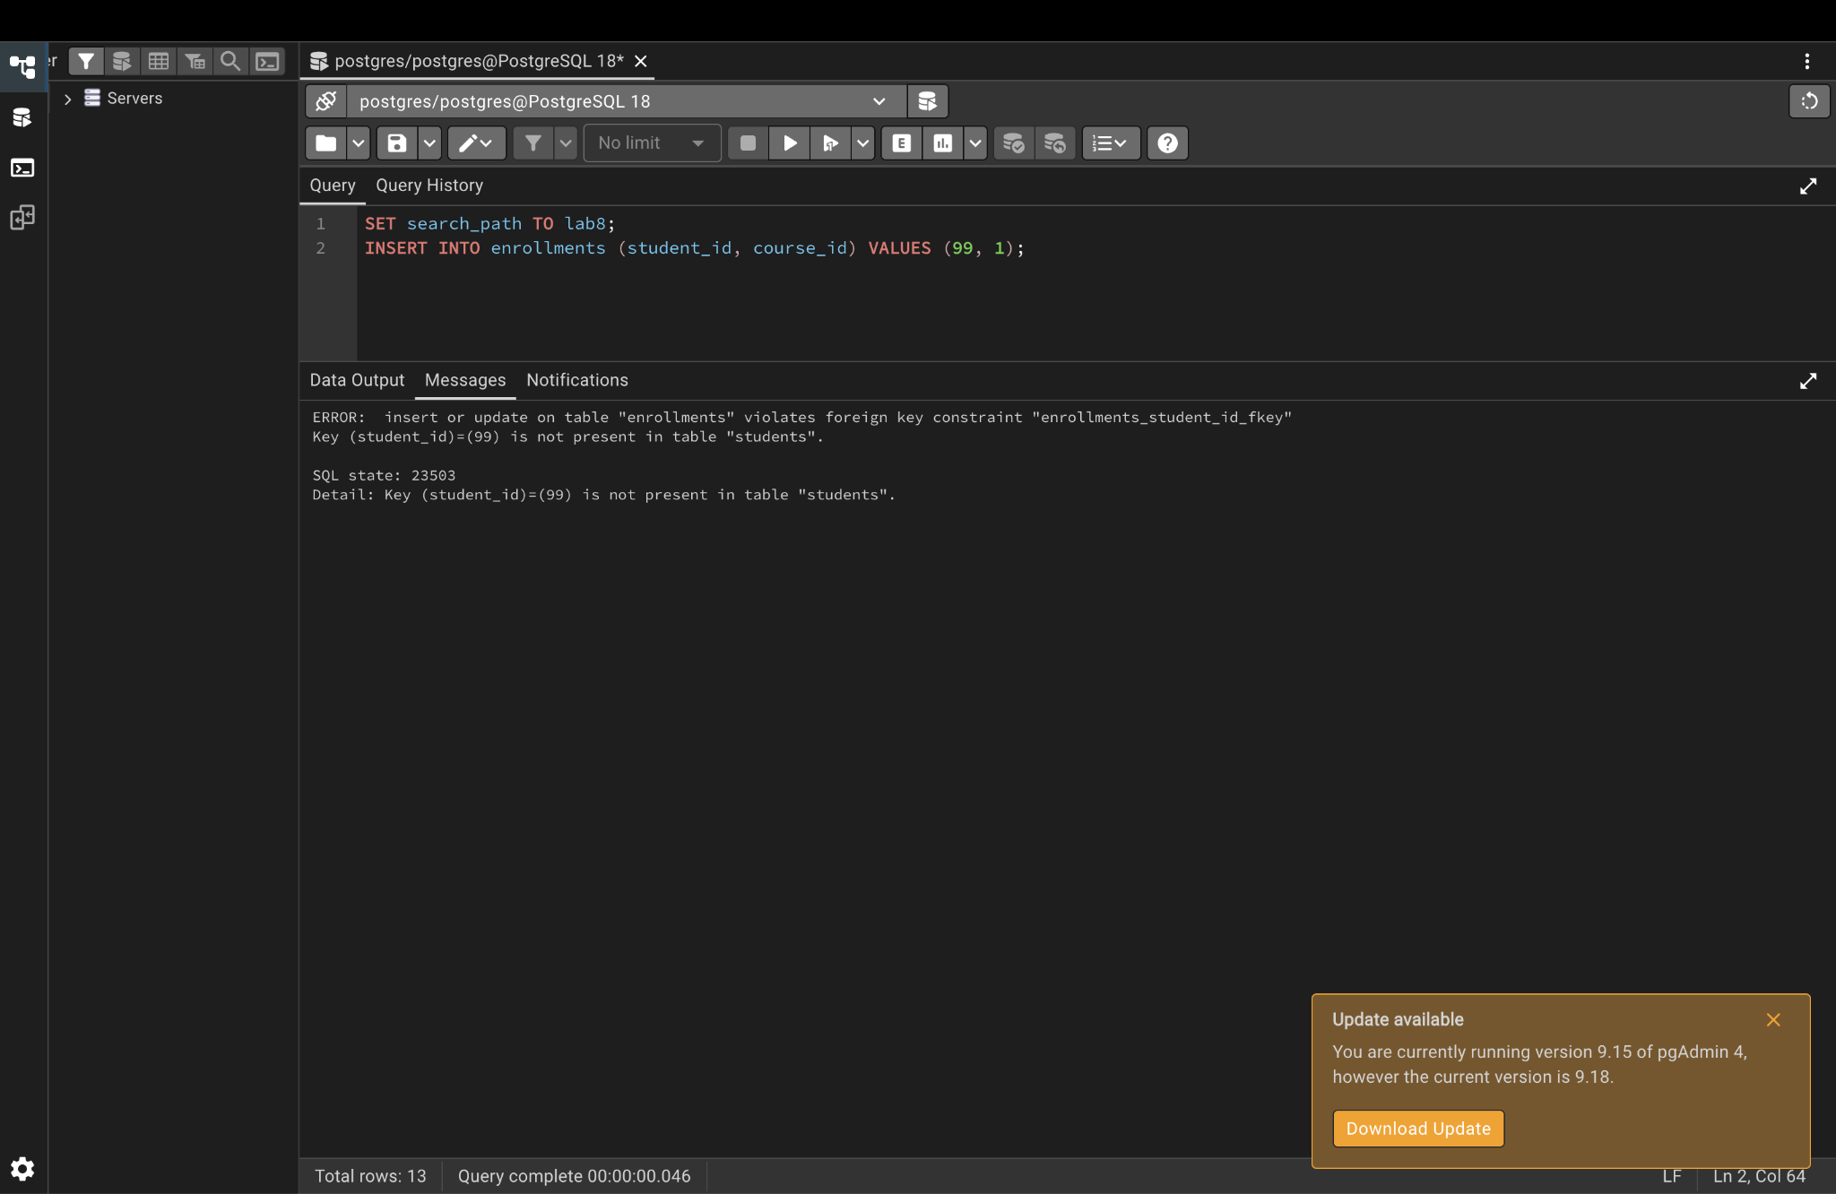

Step 11. Update rule: course 99 does not exist
UPDATE enrollments SET course_id = 99 WHERE student_id = 1 AND course_id = 1;
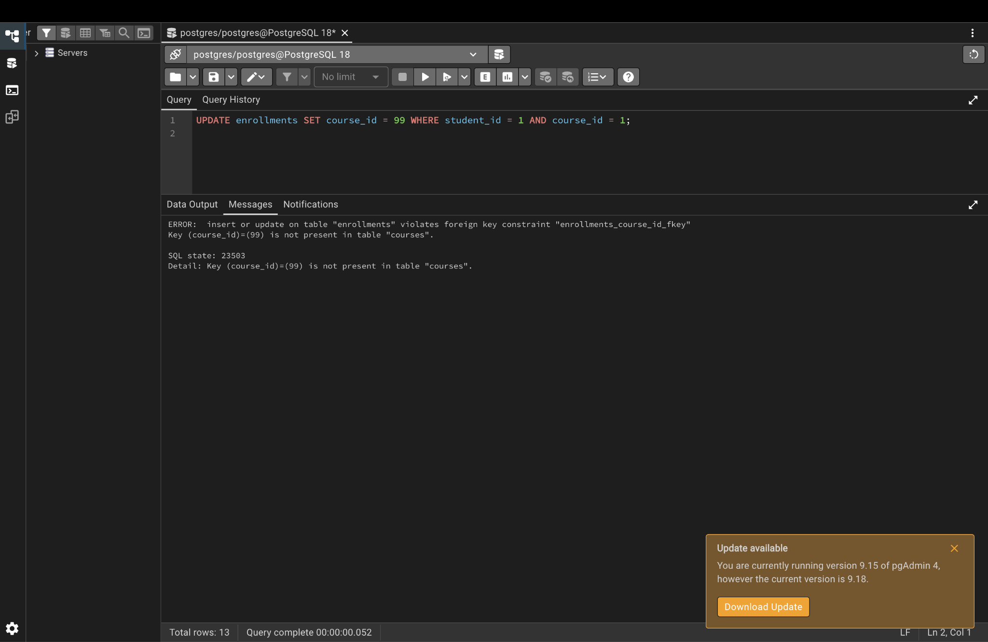

Step 12. RESTRICT blocks deleting a department that has employees
DELETE FROM departments WHERE dept_id = 3;
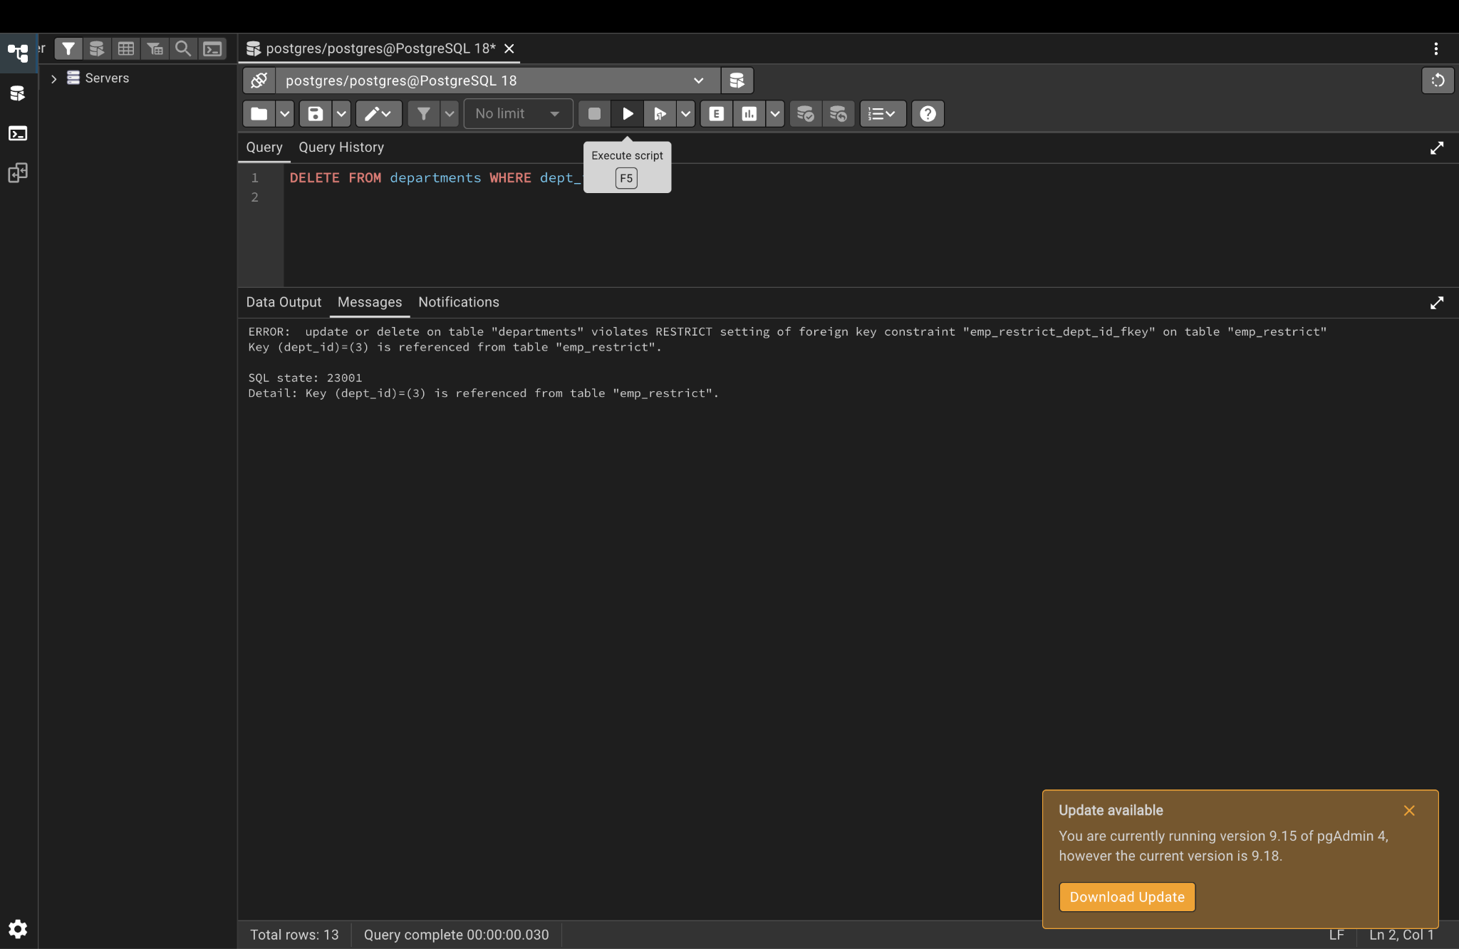

Step 13. One-to-one: a second profile for the same student is blocked
INSERT INTO student_profiles (student_id, address) VALUES (1, 'Second address');
